**Introduction to Razor Pages with Entity Framework : Workshop-2**

Welcome to the dynamic world of web development using Razor Pages and Entity Framework (EF). Razor Pages is a lightweight web framework in ASP.NET Core that enables you to build web applications with simplicity and flexibility.

**Razor Pages:**

- Emphasizes code simplicity.

- Utilizes a page-focused approach for building UI.

- Integrates seamlessly with ASP.NET Core.

**Entity Framework:**

- A powerful Object-Relational Mapping (ORM) framework.

- Simplifies database interactions in your application.

- Provides a convenient way to work with databases using C#.

**Why Combine Razor Pages with EF:**

- Rapid development with minimal boilerplate code.

- Seamless integration for building data-driven applications.

- Simplified syntax and structure for managing UI and data logic.

This powerful combination empowers developers to create efficient and scalable web applications with ease. Whether you are a beginner or an experienced developer, Razor Pages with EF offers a straightforward approach to building modern web solutions. Dive in and explore the endless possibilities of web development!

**Dear students,** for your hands-on learning experience with Razor Pages and Entity Framework, please create the following models with their respective primary and foreign key relationships:

**1. Applications:**

*Columns:*

- Id (uniqueidentifier) [Primary Key]

- UserId (uniqueidentifier) [Foreign Key: Users(Id)]

- JobId (uniqueidentifier) [Foreign Key: Jobs(Id)]

- CompanyId (uniqueidentifier) [Foreign Key: Companies(Id)]

- AppliedDate (date)

- Status (varchar(50))

**2. Companies:**

*Columns:*

- Id (uniqueidentifier) [Primary Key]

- Name (varchar(100))

- Email (varchar(50)) [Unique Constraint]

- Website (varchar(50))

- Phone (varchar(50))

- Logo (varchar(50))

- About (varchar(100))

- Vision (varchar(100))

- Mission (varchar(100))

- Location (varchar(50))

- Address (varchar(50))

- Status (varchar(50))

- CreatedDate (date)

**3. Interviews:**

*Columns:*

- Id (uniqueidentifier) [Primary Key]

- CompanyId (uniqueidentifier) [Foreign Key: Companies(Id)]

- JobId (uniqueidentifier) [Foreign Key: Jobs(Id)]

- JobseekerId (uniqueidentifier) [Foreign Key: Users(Id)]

- Date (date)

- Time (time(7))

- Location (varchar(50))

- Status (varchar(50))

- CreatedBy (uniqueidentifier) [Foreign Key: Users(Id)]

- CreatedDate (date)

*Constraints:*

- Foreign Key: CompanyId references Companies(Id)

- Foreign Key: JobId references Jobs(Id)

- Foreign Key: JobseekerId references Users(Id)

- Foreign Key: CreatedBy references Users(Id)

**4. Jobs:**

*Columns:*

- Id (uniqueidentifier) [Primary Key]

- Title (varchar(50))

- Description (varchar(50))

- Location (varchar(50))

- Experience (varchar(50))

- TypeOfWorkPlace (varchar(50))

- Salary (varchar(50))

- Responsibilities (varchar(50))

- JobType (varchar(50))

- VacanciesCount (int)

- AppliedCount (int)

- Status (varchar(50))

- CompanyId (uniqueidentifier) [Foreign Key: Companies(Id)]

- CreatedDate (date)

- CreatedBy (uniqueidentifier) [Foreign Key: Users(Id)]

*Constraints:*

- Foreign Key: CompanyId references Companies(Id)

- Foreign Key: CreatedBy references Users(Id)

**5. Qualifications:**

*Columns:*

- Id (uniqueidentifier) [Primary Key]

- UserId (uniqueidentifier) [Foreign Key: Users(Id)]

- Title (varchar(50))

- Mark (varchar(50))

- YearOfPassout (varchar(50))

- University (varchar(50))

- Status (varchar(50))

*Constraints:*

- Foreign Key: UserId references Users(Id)

**6. Skills:**

*Columns:*

- Id (uniqueidentifier) [Primary Key]

- UserId (uniqueidentifier) [Foreign Key: Users(Id)]

- Title (varchar(50))

- Status (varchar(50))

*Constraints:*

- Foreign Key: UserId references Users(Id)

**7. Users:**

*Columns:*

- Id (uniqueidentifier) [Primary Key]

- FirstName (varchar(50))

- LastName (varchar(50))

- Email (varchar(50)) [Unique Constraint]

- Gender (varchar(50))

- Location (varchar(50))

- Phone (varchar(50))

- Password (varchar(50))

- Role (varchar(50))

- About (varchar(50))

- Designation (varchar(50))

- CompanyId (uniqueidentifier) [Foreign Key: Companies(Id)]

- Status (varchar(50))

- Image (varchar(50))

- CreatedDate (date)

*Constraints:*

- Foreign Key: CompanyId references Companies(Id)

Feel free to dive in and create these models to strengthen your understanding of building database structures for web applications.

**Task: Create a Login Screen**

Your next challenge is to implement a login screen using Razor Pages and Entity Framework. Follow these steps:

**Login Screen:**

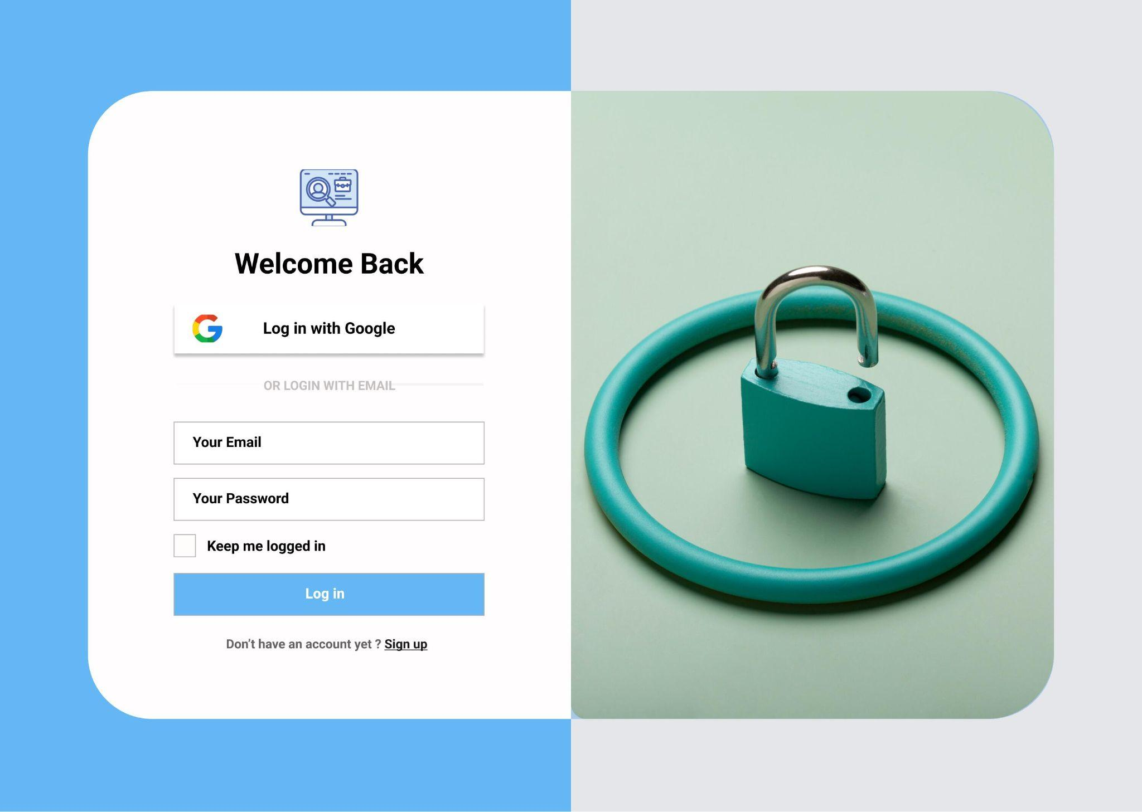

1. Design the Login Form:

- Create an HTML form with fields for the user's email and password.

2. Create a Razor Page:

- Create a new Razor Page (e.g., `Login.cshtml`).

3. Model:

- Create a model (e.g., `LoginModel.cs`) to represent the data from the login form.

4. Backend Logic:

- In the `LoginModel.cs`, implement the backend logic to handle login submissions.

- Use Entity Framework to check the database for the user's information.

5. Validation:

- Implement proper validation for user input in the Razor Page and the model.

- Validate the email format and ensure the password matches the stored hash.

6. Redirect:

- After a user successfully logs in, you can redirect them to a dashboard or any other appropriate page.

**Database Verification:**

- After a user registers or logs in, manually check the database using a database management tool or SQL queries to verify that the user's information has been correctly stored.

This will build your ability to design Razor Pages, work with Entity Framework for database interactions, and implement proper validation for user input. Happy coding! 😊